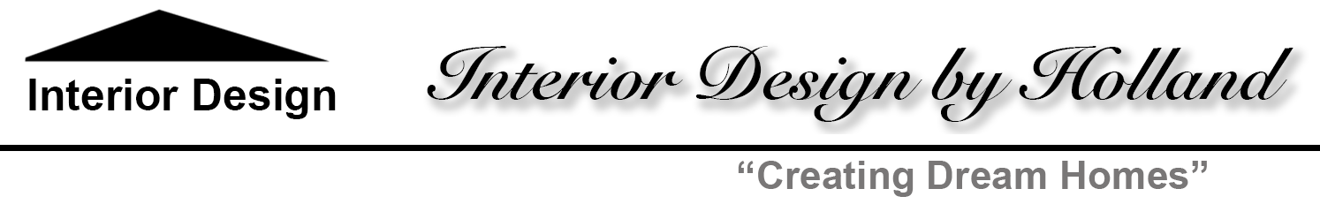

**Water Closet Brief**

**Overall Style:**

The style of the Water Closet is contemporary in the selections of the barley blue wallpaper, white cabinetry design, wood pony wall for privacy between the vanity and sink and easy to clean wall hung toilet. The room is designed to allow for everything to go into a planned space without any clutter.

**Interior Design Vision:**

The Water Closet is designed as a main floor powder room for the family and guests. Since there is a lot of traffic it needs to be attractive and durable. Additional storage was added to hold hand towels and toilet paper so everything can be neatly tucked away for a clean look. Shelves were added to place tissues and decorative items. The rug blends well with the white cabinetry and hardwood floors and adds additional comfort under foot.

**Elements to Achieve Design:**

The selection of contemporary cabinetry, wall hung toilet, and modern lights over the vanity contribute to the design of the room. Polished chrome hardware is used throughout the room providing consistency and contrast to the dark blue wallpaper behind it. The vanity mirror multi-light provides a high-quality aesthetic. The natural elements include two plants in white containers, the wood pony privacy wall, wood floors, and wood shelves.

**Cohesive Connections Across Rooms:**

Building on the neutral base, blue is the primary color used in the Water Closet with the use of the dark blue barley wallpaper on all walls. The use of blue in the Living Room, Dining Room, and TV/Game/Study provide connections to other rooms in the house. All floors are consistent with the use of white oak hardwood flooring, which is durable and attractive. Contemporary furniture, cabinetry, and accessories together create consistency with the entire main level of the home. All rooms have light area rugs to keep the space as expansive and comfortable as possible.

**Mood/Feeling of the Room:**

The blue, blue-green, and green, analogous color scheme uses a cool color palette found to provide a calm environment. A calm and relaxed environment describes the mood created by using these colors in the design. The contemporary casual comfortable furnishing contributes to the relaxed environment created for the main level family and guest powder room.